Jenkins system config with testlink api key

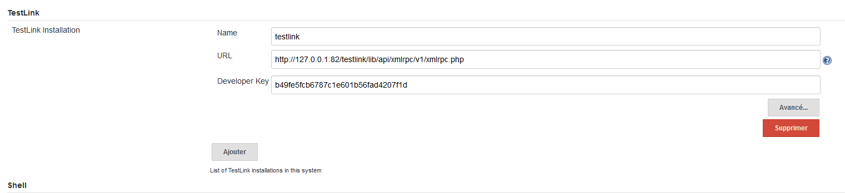

The field name is the one you need to choose in the jenkins job inorder to match up with the testlink instance running on 127….